Chapter 04. Building a Social Website

In the preceding chapter, you learned how to implement a tagging system and how to recommend similar posts. You implemented custom template tags and filters. You also learned how to create sitemaps and feeds for your site, and you built a full-text search engine using PostgreSQL.

In this chapter, you will learn how to develop user account functionalities to create a social website, including user registration, password management, profile editing, and authentication. We will implement social features on this site in the next few chapters, to let users share images and interact with each other. Users will be able to bookmark any image on the internet and share it with other users. They will also be able to see activity on the platform from the users they follow and like/unlike the images shared by them.

This chapter will cover the following topics:

- Creating a login view
- Using the Django authentication framework
- Creating templates for Django login, logout, password change, and password reset views
- Creating user registration views
- Extending the user model with a custom profile model
- Configuring the project for media file uploads

Functional overview
Figure 4.1 shows a representation of the views, templates, and functionalities that will be built in this chapter:
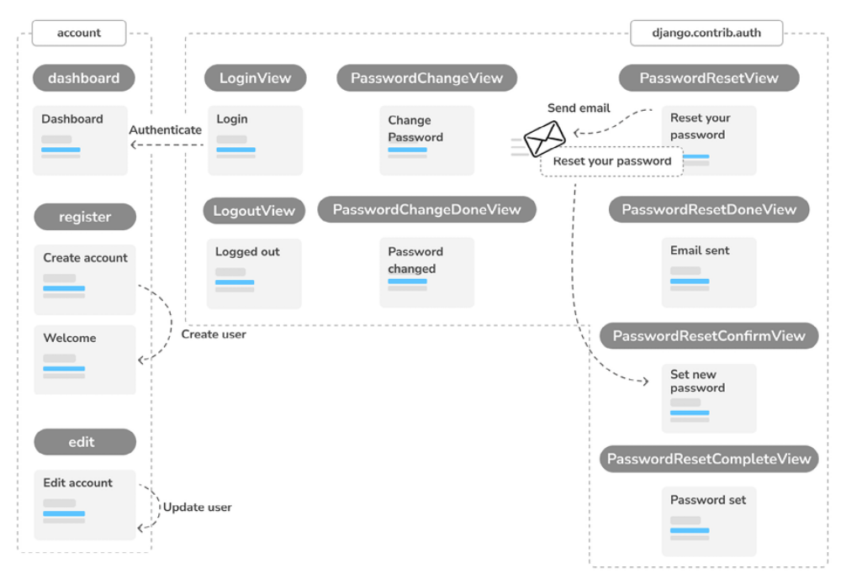
Figure 4.1: Diagram of functionalities built in Chapter 4

In this chapter, you will create a new project and use the login, logout, password change, and password recovery views provided by Django in the django.contrib.auth package. You will create templates for the authentication views, and you will create a dashboard view that users will have access to when they successfully authenticate. You will implement user registration with the register view. Finally, you will extend the user model
with a custom Profile model and create the edit view to allow users to edit their profile.
The source code for this chapter can be found at
https://github.com/PacktPublishing/Django-5-byexample/tree/main/Chapter04.

All Python packages used in this chapter are included in the requirements.txt file in the source code for the chapter. You can follow the instructions to install each Python package in the following sections, or you can install all requirements at once with the command python -m pip install -r requirements.txt .
Creating a social website project
We are going to create a social application that will allow users to share images that they find on the internet. This project is relevant because it will help you understand how to build social capabilities into your site, as well as how to implement advanced functionalities with Django and JavaScript.

- For our image-sharing website, we will need to build the following elements:

- An authentication system for users to register, log in, edit their profile, and change or reset their password

- Social authentication to sign in with services such as Google

- Functionality to display shared images and a system for users to share images from any website

- An activity stream that allows users to see the content uploaded by the people that they follow

- A follow system to allow users to follow each other on the website

This chapter will address the first point on the list. The rest of the points will be covered in Chapters 5 to 7.

Starting the social website project
We will start by setting up the virtual environment for the project and creating the initial project structure.

Open the terminal and use the following commands to create a virtual environment for your project:
mkdir env
python -m venv env/bookmarks

If you are using Linux or macOS, run the following command to activate your virtual environment:
source env/bookmarks/bin/activate

If you are using Windows, use the following command instead:
.\env\bookmarks\Scripts\activate

The shell prompt will display your active virtual environment, as follows:
(bookmarks)laptop:~ zenx$

Install Django in your virtual environment with the following command:
python -m pip install Django~=5.0.4

Run the following command to create a new project:
django-admin startproject bookmarks

The initial project structure has been created. Use the following commands to get into your project directory and create a new application named
account :
cd bookmarks/
django-admin startapp account

Remember that you should add the new application to your project by adding the application’s name to the INSTALLED_APPS setting in the settings.py file.

Edit settings.py and add the following line highlighted in bold to the
INSTALLED_APPS list before any of the other installed apps:
INSTALLED_APPS = [
'account.apps.AccountConfig',
'django.contrib.admin',
'django.contrib.auth',
'django.contrib.contenttypes',
'django.contrib.sessions',
'django.contrib.messages',
'django.contrib.staticfiles',
]

Django looks for templates in the application template directories by order of appearance in the INSTALLED_APPS setting. The django.contrib.admin app includes standard authentication templates, which we will override in the account application. Usually, we place our own apps at the end of the list. In this case, we place the application first in the INSTALLED_APPS setting to ensure that our custom authentication templates will be used, instead of the authentication templates contained in django.contrib.admin .

Run the following command to sync the database with the models of the default applications included in the INSTALLED_APPS setting:
python manage.py migrate

You will see that all the initial Django database migrations get applied. The database tables corresponding to the Django models of the installed applications have been created. Next, we will build an authentication system into our project using the Django authentication framework.

Using the Django authentication framework
Django comes with a built-in authentication framework that can handle user authentication, sessions, permissions, and user groups. The authentication system includes views for common user actions such as logging in, logging out, password change, and password reset.

The authentication framework is located at django.contrib.auth and is used by other Django contrib packages. Remember that we already used the authentication framework in Chapter 1, Building a Blog Application, to create a superuser for the blog application to access the administration site. When we create a new Django project using the startproject command, the authentication framework is included in the default settings of our project. It consists of the django.contrib.auth application and the following two middleware classes found in the MIDDLEWARE setting of our project:

- AuthenticationMiddleware : Associates users with requests using sessions

- SessionMiddleware : Handles the current session across requests

Middleware is classes with methods that are globally executed during the request or response phase. You will use middleware classes on several occasions throughout this book, and you will learn how to create custom middleware in Chapter 17, Going Live.

The authentication framework also includes the following models that are defined in django.contrib.auth.models :

- User : A user model with basic fields; the main fields of this model are username , password , email , first_name , last_name , and is_active

- Group : A group model to categorize users

- Permission : Flags for users or groups to perform certain actions

The framework also includes default authentication views and forms, which you will use later.
Creating a login view
We will start this section by using the Django authentication framework to allow users to log in to the website. We will create a view that will perform the following actions to log in a user:
1. Present the user with a login form

2. Get the username and password provided by the user when they submit the form

3. Authenticate the user against the data stored in the database

4. Check whether the user is active

5. Log the user into the website and start an authenticated session

We will start by creating the login form.

Create a new forms.py file in the account application directory and add the following lines to it:
from django import forms
class LoginForm(forms.Form):
username = forms.CharField()
password = forms.CharField(widget=forms.PasswordInput)

This form will be used to authenticate users against the database. The PasswordInput widget is used to render the password HTML element. This will include type="password" in the HTML so that the browser treats it as a password input.

Edit the views.py file of the account application and add the following code to it:
from django.contrib.auth import authenticate, login
from django.http import HttpResponse
from django.shortcuts import render
from .forms import LoginForm
def user_login(request):
if request.method == 'POST':
form = LoginForm(request.POST)
if form.is_valid():
cd = form.cleaned_data
user = authenticate(
request,
username=cd['username'],
password=cd['password']
)
if user is not None:
if user.is_active:
login(request, user)
return HttpResponse('Authenticated successfu
else:
return HttpResponse('Disabled account')
else:
return HttpResponse('Invalid login')
else:
form = LoginForm()
return render(request, 'account/login.html', {'form': form})

This is what the basic login view does:

When the user_login view is called with a GET request, a new login form is instantiated with form = LoginForm() . The form is then passed to the template.

When the user submits the form via POST , the following actions are performed:

The form is instantiated with the submitted data with form = LoginForm(request.POST) .

The form is validated with form.is_valid() . If it is not valid, the form errors will be displayed later in the template (for example, if the user didn’t fill in one of the fields).

If the submitted data is valid, the user gets authenticated against the database using the authenticate() method. This method takes the request object, the username , and the password parameters and returns the User object if the user has been successfully authenticated, or None otherwise. If the user has not been successfully authenticated, a raw HttpResponse is returned with an Invalid login message.

If the user is successfully authenticated, the user status is checked by accessing the is_active attribute. This is an attribute of Django’s user model. If the user is not active, an HttpResponse is returned with a Disabled account message.

If the user is active, the user is logged into the site. The user is set in the session by calling the login() method. An Authenticated successfully message is returned.

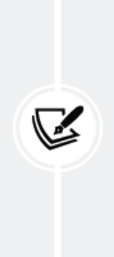
Note the difference between authenticate() and login() :
authenticate() verifies the user’s credentials and, upon
validation, returns a User object representing the
authenticated user. In contrast, login() sets the user in the
current session by incorporating the authenticated User
object into the current session context.

Now, we will create a URL pattern for this view:

Create a new urls.py file in the account application directory and add the following code to it:
from django.urls import path
from . import views
urlpatterns = [
path('login/', views.user_login, name='login'),
]

Edit the main urls.py file located in your bookmarks project directory, import include , and add the URL patterns of the account application, as follows. The new code is highlighted in bold:
from django.contrib import admin
from django.urls import include, path
urlpatterns = [
path('admin/', admin.site.urls),
path('account/', include('account.urls')),
]

The login view can now be accessed with a URL.

Let’s create a template for this view. Since there are no templates in the project yet, we will start by creating a base template that will be extended by the login template:
Create the following files and directories inside the account application
directory:
templates/
account/
login.html
base.html

Edit the base.html template and add the following code to it:
{% load static %}
<!DOCTYPE html>
<html>
<head>
<title>{% block title %}{% endblock %}</title>
<link href="{% static "css/base.css" %}" rel="stylesheet">
</head>
<body>
<div id="header">
<span class="logo">Bookmarks</span>
</div>
<div id="content">
{% block content %}
{% endblock %}
</div>
</body>
</html>

This will be the base template for the website. As you did in your previous project, include the CSS styles in the main template. You can find these static files in the code that comes with this chapter. Copy the static/ directory of the account application from the chapter’s source code to the same location in your project so that you can use the static files. You can find the directory’s contents at
https://github.com/PacktPublishing/Django-5-by-Example/tree/master/Chapter04/bookmarks/account/static.

The base template defines a title block and a content block that can be filled with content by the templates that extend from it.

Let’s fill in the template for your login form.

Open the account/login.html template and add the following code to it:
{% extends "base.html" %}
{% block title %}Log-in{% endblock %}
{% block content %}
<h1>Log-in</h1>
<p>Please, use the following form to log-in:</p>
<form method="post">
{{ form.as_p }}
{% csrf_token %}
<p><input type="submit" value="Log in"></p>
</form>
{% endblock %}

This template includes the form that is instantiated in the view. Since your form will be submitted via POST , you will include the {% csrf_token %} template tag for cross-site request forgery (CSRF) protection. You learned about CSRF protection in Chapter 2, Enhancing Your Blog with Advanced Features.

There are no users in the database yet. You will need to create a superuser first to access the administration site to manage other users.

Execute the following command in the shell prompt:
python manage.py createsuperuser
You will see the following output. Enter your desired username, email, and password, as follows:
Username (leave blank to use 'admin'): admin
Email address: admin@admin.com
Password: ********
Password (again): ********

Then, you will see the following success message:
Superuser created successfully.

Run the development server using the following command:
python manage.py runserver

Open http://127.0.0.1:8000/admin/ in your browser. Access the administration site using the credentials of the user you just created. You will see the Django administration site, including the User and Group models of the Django authentication framework.
It will look as follows:
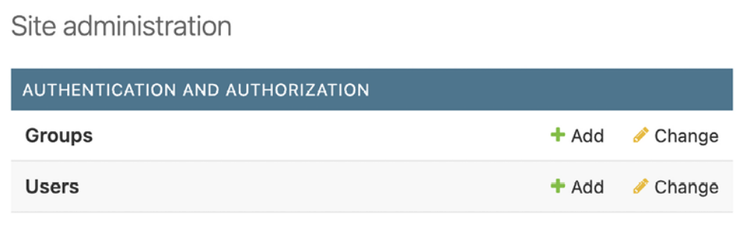
Figure 4.2: The Django administration site index page including Users and Groups

In the Users row, click on the Add link.

Create a new user using the administration site as follows:
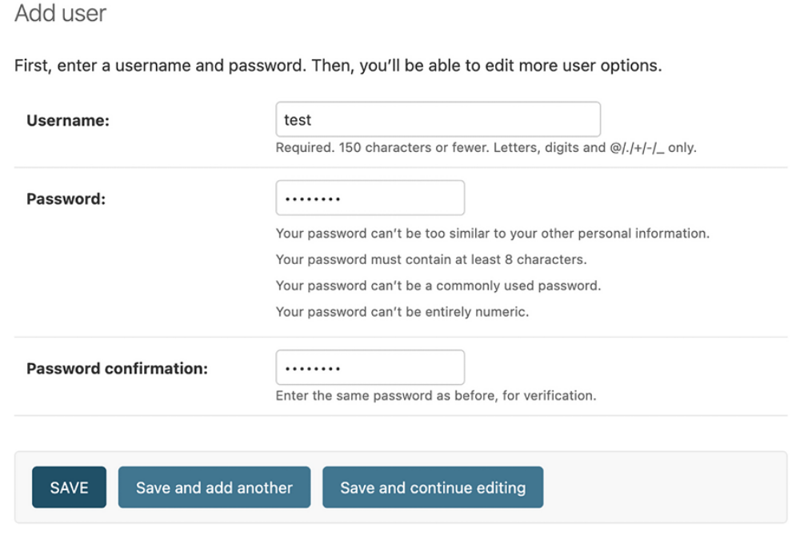
Figure 4.3: The Add user form on the Django administration site

Enter the user details and click on the SAVE button to save the new user in
the database.

Then, in Personal info, fill in the First name, Last name, and Email address fields as follows, and then click on the SAVE button to save the changes:
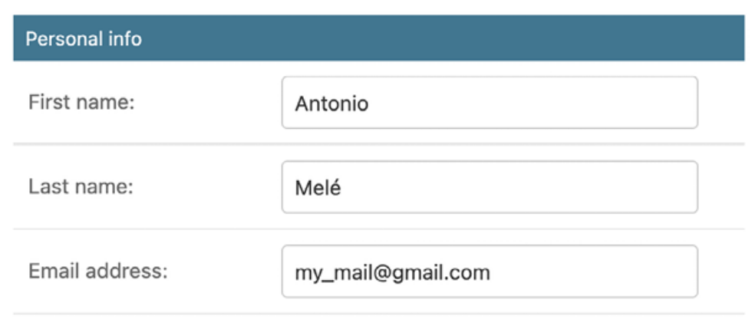
Figure 4.4: The user editing form on the Django administration site

Open http://127.0.0.1:8000/account/login/ in your browser. You shouldsee the rendered template, including the login form:
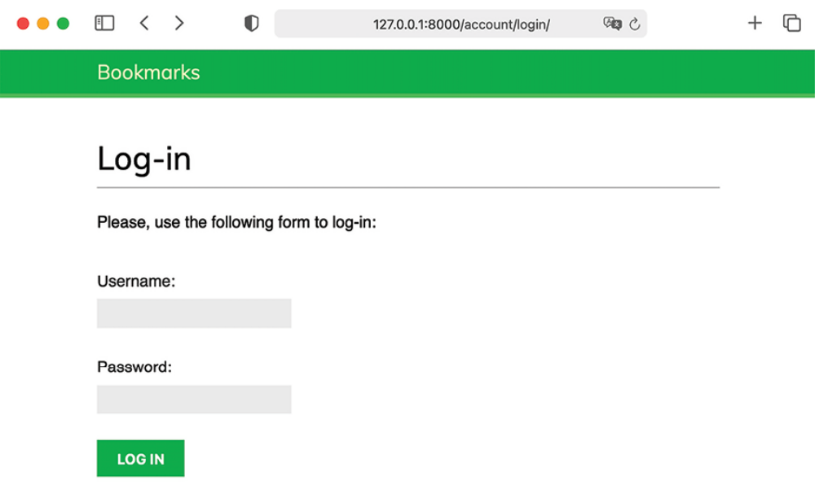
Figure 4.5: The user Log-in page

Enter invalid credentials and submit the form. You should get the following Invalid login response:
Figure 4.6: The invalid login plain text response

Enter valid credentials; you will get the following Authenticated successfully response:
Figure 4.7: The successful authentication plain text response

Now, you have learned how to authenticate users and create your own authentication view. You can build your own auth views, but Django ships with ready-to-use authentication views that you can leverage.

Using Django’s built-in authentication views
Django includes several forms and views in the authentication framework that you can use right away. The login view we have created is a good exercise to understand the process of user authentication in Django.

However, you can use the default Django authentication views in most cases.

Django provides the following class-based views to deal with authentication.

All of them are located in django.contrib.auth.views :

- LoginView : Handles a login form and logs in a user

- LogoutView : Logs out a user

Django provides the following views to handle password changes:

- PasswordChangeView : Handles a form to change the user’s password

- PasswordChangeDoneView : The success view that the user is redirected to after a successful password change

Django also includes the following views to allow users to reset their password:

- PasswordResetView : Allows users to reset their password. It generates a one-time-use link with a token and sends it to a user’s email account

- PasswordResetDoneView : Tells users that an email—including a link to reset their password—has been sent to them

- PasswordResetConfirmView : Allows users to set a new password

- PasswordResetCompleteView : The success view that the user isredirected to after successfully resetting their password

These views can save you a lot of time when building any web application with user accounts. The views use default values that can be overridden, such as the location of the template to be rendered, or the form to be used by the view.

You can get more information about the built-in authentication views at
https://docs.djangoproject.com/en/5.0/topics/auth/default/#all-authentication-views.

Login and logout views
To learn how to use Django’s authentication views, we will substitute our custom login view with Django’s built-in equivalent and also integrate a logout view.
Edit the urls.py file of the account application and add the code highlighted in bold:
from django.contrib.auth import views as auth_views
from django.urls import path
from . import views
urlpatterns = [
# previous login url
# path('login/', views.user_login, name='login'),
# login / logout urls
path('login/', auth_views.LoginView.as_view(), name='login')
path('logout/', auth_views.LogoutView.as_view(), name='logou
]

In the preceding code, we have commented out the URL pattern for the user_login view that we created previously. We’ll now use the LoginView view of Django’s authentication framework. We have also added a URL pattern for the LogoutView view.

Create a new directory inside the templates/ directory of the account application and name it registration . This is the default path where the Django authentication views expect your authentication templates to be.

The django.contrib.admin module includes authentication templates that are used for the administration site, like the login template. By placing the account application at the top of the INSTALLED_APPS setting when configuring the project, we ensured that Django would use our authentication templates instead of the ones defined in any other application.

Create a new file inside the templates/registration/ directory, name it login.html , and add the following code to it:
{% extends "base.html" %}
{% block title %}Log-in{% endblock %}
{% block content %}
<h1>Log-in</h1>
{% if form.errors %}
<p>
Your username and password didn't match.
Please try again.
</p>
{% else %}
<p>Please, use the following form to log-in:</p>
{% endif %}
<div class="login-form">
<form action="{% url 'login' %}" method="post">
{{ form.as_p }}
{% csrf_token %}
<input type="hidden" name="next" value="{{ next }}" />
<p><input type="submit" value="Log-in"></p>
</form>
</div>
{% endblock %}

This login template is quite similar to the one we created before. Django uses the AuthenticationForm form located at django.contrib.auth.forms by default. This form tries to authenticate the user and raises a validation error if the login is unsuccessful. We use {% if form.errors %} in the template to check whether the credentials provided are wrong.

We have added a hidden HTML <input> element to submit the value of a variable called next . This variable is provided to the login view if you pass a parameter named next to the request, for example, by accessing http://127.0.0.1:8000/account/login/?next=/account/ .

The next parameter has to be a URL. If this parameter is given, the Django login view will redirect the user to the given URL after a successful login.

Now, create a logged_out.html template inside the templates/registration/ directory and make it look like this:
{% extends "base.html" %}
{% block title %}Logged out{% endblock %}
{% block content %}
<h1>Logged out</h1>
<p>
You have been successfully logged out.
You can <a href="{% url "login" %}">log-in again</a>.
</p>
{% endblock %}

This is the template that Django will display after the user logs out.

We have added the URL patterns and templates for the login and logout views. Users can now log in and out using Django’s authentication views.

Now, we will create a new view to display a dashboard when users log in to their accounts.

Edit the views.py file of the account application and add the following code to it:
from django.contrib.auth.decorators import login_required
@login_required
def dashboard(request):
return render(
request,
'account/dashboard.html',
{'section': 'dashboard'}
)

We have created the dashboard view, and we have applied to it the login_required decorator of the authentication framework. The login_required decorator checks whether the current user is authenticated.

If the user is authenticated, it executes the decorated view; if the user is not authenticated, it redirects the user to the login URL, with the originally requested URL as a GET parameter named next .

By doing this, the login view redirects users to the URL that they were trying to access after they successfully logged in. Remember that we added a hidden <input> HTML element named next in the login template for this purpose.

We have also defined a section variable. We will use this variable to highlight the current section in the main menu of the site.

Next, we need to create a template for the dashboard view.

Create a new file inside the templates/account/ directory and name it dashboard.html . Add the following code to it:
{% extends "base.html" %}
{% block title %}Dashboard{% endblock %}
{% block content %}
<h1>Dashboard</h1>
<p>Welcome to your dashboard.</p>
{% endblock %}

Edit the urls.py file of the account application and add the following URL pattern for the view. The new code is highlighted in bold:
urlpatterns = [
# previous login url
# path('login/', views.user_login, name='login'),
# login / logout urls
path('login/', auth_views.LoginView.as_view(), name='login')
path('logout/', auth_views.LogoutView.as_view(), name='logou
path('', views.dashboard, name='dashboard'),
]
Edit the settings.py file of the project and add the following code to it:
LOGIN_REDIRECT_URL = 'dashboard'
LOGIN_URL = 'login'
LOGOUT_URL = 'logout'

We have defined the following settings:

- LOGIN_REDIRECT_URL : Tells Django which URL to redirect the user to after a successful login if no next parameter is present in the request

- LOGIN_URL : The URL to redirect the user to log in (for example, views using the login_required decorator)

- LOGOUT_URL : The URL to redirect the user to log out

We have used the names of the URLs that we previously defined with the name attribute of the path() function in the URL patterns. Hardcoded URLs instead of URL names can also be used for these settings.

Let’s summarize what we have done so far:

- We have added the built-in Django authentication login and logout views to the project.

- We have created custom templates for both views and defined a simple dashboard view to redirect users after they log in.

- Finally, we have added settings for Django to use these URLs by default.

Now, we will add a link to the login URL and a button to log out to the base template. In order to do this, we have to determine whether the current user is logged in or not to display the appropriate action for each case. The current user is set in the HttpRequest object by the authentication middleware. You can access it with request.user . The request object contains a User object even if the user is not authenticated. A nonauthenticated
user is set in the request as an instance of AnonymousUser . The best way to check if the current user is authenticated is by accessing the read-only attribute, is_authenticated .

Edit the templates/base.html template by adding the following lines highlighted in bold:
{% load static %}
<!DOCTYPE html>
<html>
<head>
<title>{% block title %}{% endblock %}</title>
<link href="{% static "css/base.css" %}" rel="stylesheet">
</head>
<body>
<div id="header">
<span class="logo">Bookmarks</span>
{% if request.user.is_authenticated %}
<ul class="menu">
<li {% if section == "dashboard" %}class="selected"{% endif %}>
<a href="{% url "dashboard" %}">My dashboard</a>
</li>
<li {% if section == "images" %}class="selected"{% endif %}>
<a href="#">Images</a>
</li>
<li {% if section == "people" %}class="selected"{% endif %}>
<a href="#">People</a>
</li>
</ul>
{% endif %}
<span class="user">
{% if request.user.is_authenticated %}
Hello {{ request.user.first_name|default:request.user.us
<form action="{% url "logout" %}" method="post">
<button type="submit">Logout</button>
{% csrf_token %}
</form>
{% else %}
<a href="{% url "login" %}">Log-in</a>
{% endif %}
</span>
</div>
<div id="content">
{% block content %}
{% endblock %}
</div>
</body>
</html>

The site’s menu is only displayed to authenticated users. The section variable is checked to add a selected class attribute to the menu <li> list item of the current section. By doing so, the menu item that corresponds to the current section will be highlighted using CSS. The user’s first name and a button to log out are displayed if the user is authenticated; a link to log in is displayed otherwise. If the user’s name is empty, the username is displayed instead by using

request.user.first_name|default:request.user.username . Note that for the logout action, we use a form with the method POST and a button to submit the form. This is because the LogoutView requires POST requests.
Open http://127.0.0.1:8000/account/login/ in your browser. You should see the Log-in page. Enter a valid username and password and click on the Log-in button. You should see the following screen:
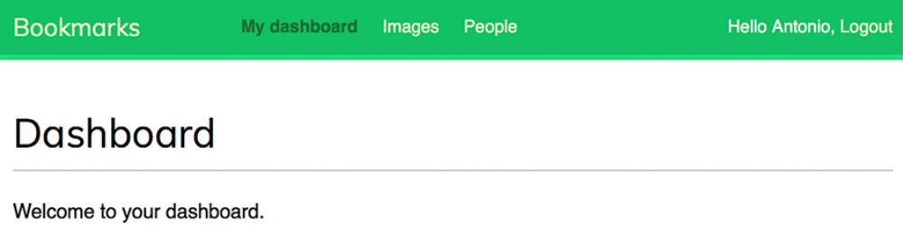
Figure 4.8: The Dashboard page

The My dashboard menu item is highlighted with CSS because it has a selected class. Since the user is authenticated, the first name of the user is displayed on the right side of the header. Click on the Logout button. You should see the following page:
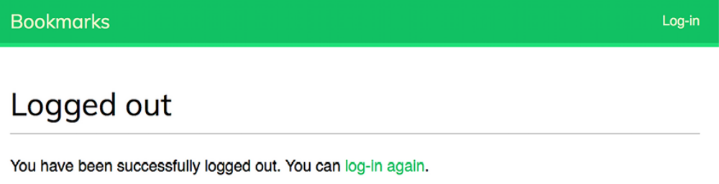
Figure 4.9: The Logged out page

On this page, you can see that the user is logged out, and therefore, the menu of the website is not displayed. The link displayed on the right side of the header is now Log-in.

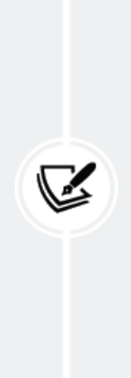
If you see the Logged out page of the Django administration
site instead of your own Logged out page, check the
INSTALLED_APPS setting of your project and make sure that
django.contrib.admin comes after the account application.
Both applications contain logged-out templates located in the
same relative path. The Django template loader will go
through the different applications in the INSTALLED_APPS list
and use the first template it finds.

Change password views
We need users to be able to change their password after they log in to the site. We will integrate the Django authentication views to change passwords.

Open the urls.py file of the account application and add the following URL patterns highlighted in bold:
urlpatterns = [
# previous login url
# path('login/', views.user_login, name='login'),
# login / logout urls
path('login/', auth_views.LoginView.as_view(), name='login')
path('logout/', auth_views.LogoutView.as_view(), name='logou
# change password urls
path(
'password-change/',
auth_views.PasswordChangeView.as_view(),
name='password_change'
),
path(
'password-change/done/',
auth_views.PasswordChangeDoneView.as_view(),
name='password_change_done'
),
path('', views.dashboard, name='dashboard'),
]

The PasswordChangeView view will handle the form to change the password, and the PasswordChangeDoneView view will display a success message after the user has successfully changed their password. Let’s create a template for each view.

Add a new file inside the templates/registration/ directory of the account application and name it password_change_form.html . Add the following code to it:
{% extends "base.html" %}
{% block title %}Change your password{% endblock %}
{% block content %}
<h1>Change your password</h1>
<p>Use the form below to change your password.</p>
<form method="post">
{{ form.as_p }}
<p><input type="submit" value="Change"></p>
{% csrf_token %}
</form>
{% endblock %}

The password_change_form.html template includes the form to change the password.

Now, create another file in the same directory and name it password_change_done.html . Add the following code to it:
{% extends "base.html" %}
{% block title %}Password changed{% endblock %}
{% block content %}
<h1>Password changed</h1>
<p>Your password has been successfully changed.</p>
{% endblock %}

The password_change_done.html template only contains the success message to be displayed when the user has successfully changed their password.

Open http://127.0.0.1:8000/account/password-change/ in your browser. If you are not logged in, the browser will redirect you to the Log-in page. After you are successfully authenticated, you will see the following change password page:
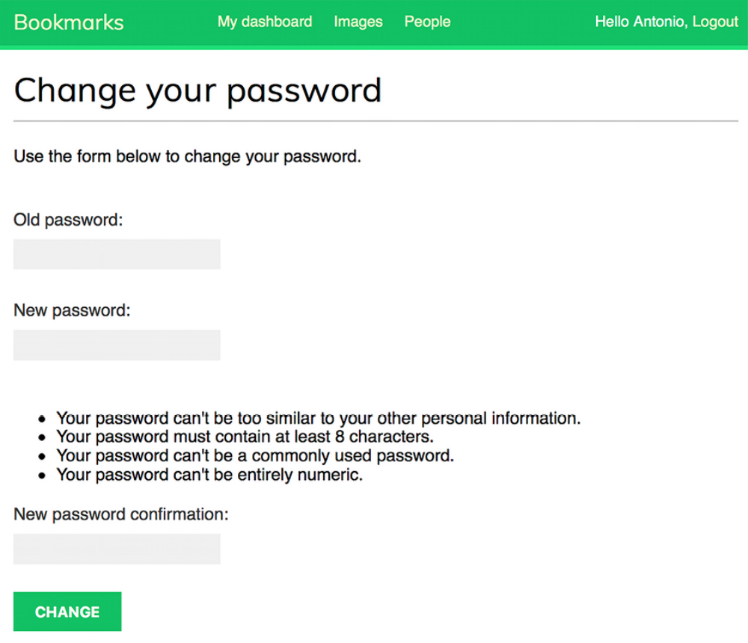
Figure 4.10: The change password form
Fill in the form with your current password and your new password, and then click on the CHANGE button. You will see the following success page:
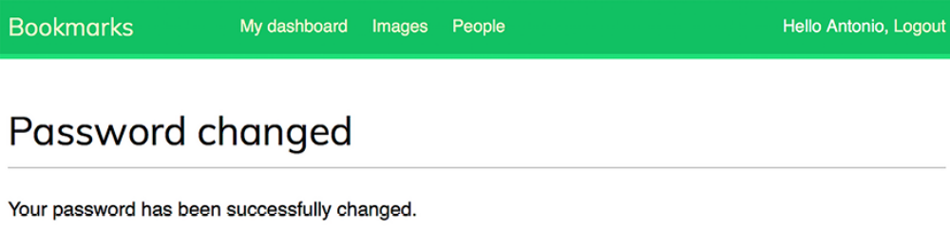
Figure 4.11: The successful change password page
Log out and log in again using your new password to verify that everything works as expected.

Reset password views
If users forget their password, they should be able to recover their account. We will implement a password reset feature. This will enable users to regain access to their account by receiving a password reset email that contains a secure link, generated with a unique token, allowing them to create a new password.

Edit the urls.py file of the account application and add the following URL patterns highlighted in bold:
urlpatterns = [
# previous login url
# path('login/', views.user_login, name='login'),
# login / logout urls
path('login/', auth_views.LoginView.as_view(), name='login')
path('logout/', auth_views.LogoutView.as_view(), name='logou
# change password urls
path(
'password-change/',
auth_views.PasswordChangeView.as_view(),
name='password_change'
),
path(
'password-change/done/',
auth_views.PasswordChangeDoneView.as_view(),
name='password_change_done'
),
# reset password urls
path(
'password-reset/',
auth_views.PasswordResetView.as_view(),
name='password_reset'
),
path(
'password-reset/done/',
auth_views.PasswordResetDoneView.as_view(),
name='password_reset_done'
),
path(
'password-reset/<uidb64>/<token>/',
auth_views.PasswordResetConfirmView.as_view(),
name='password_reset_confirm'
),
path('password-reset/complete/',
auth_views.PasswordResetCompleteView.as_view(),
name='password_reset_complete'
),
path('', views.dashboard, name='dashboard'),
]

Add a new file to the templates/registration/ directory of the account application and name it password_reset_form.html . Add the following code to it:
{% extends "base.html" %}
{% block title %}Reset your password{% endblock %}
{% block content %}
<h1>Forgotten your password?</h1>
<p>Enter your e-mail address to obtain a new password.</p>
<form method="post">
{{ form.as_p }}
<p><input type="submit" value="Send e-mail"></p>
{% csrf_token %}
</form>
{% endblock %}

Now, create another file in the same directory and name it password_reset_email.html . Add the following code to it:
Someone asked for password reset for email {{ email }}. Follow t
{{ protocol }}://{{ domain }}{% url "password_reset_confirm" uid
Your username, in case you've forgotten: {{ user.get_username }}

The password_reset_email.html template will be used to render the email sent to users to reset their password. It includes a reset token that is generated by the view.

Create another file in the same directory and name it password_reset_done.html . Add the following code to it:
{% extends "base.html" %}
{% block title %}Reset your password{% endblock %}
{% block content %}
<h1>Reset your password</h1>
<p>We've emailed you instructions for setting your password.</p>
<p>If you don't receive an email, please make sure you've entere
{% endblock %}
Create another template in the same directory and name it password_reset_confirm.html . Add the following code to it:
{% extends "base.html" %}
{% block title %}Reset your password{% endblock %}
{% block content %}
<h1>Reset your password</h1>
{% if validlink %}
<p>Please enter your new password twice:</p>
<form method="post">
{{ form.as_p }}
{% csrf_token %}
<p><input type="submit" value="Change my password" /></p>
</form>
{% else %}
<p>The password reset link was invalid, possibly because it
{% endif %}
{% endblock %}

In this template, we confirm whether the link to reset the password is valid by checking the validlink variable. The view PasswordResetConfirmView checks the validity of the token provided in the URL and passes the validlink variable to the template. If the link is valid, the user password reset form is displayed. Users can only set a new password if they have a valid reset password link.

Create another template and name it password_reset_complete.html . Enter the following code into it:
{% extends "base.html" %}
{% block title %}Password reset{% endblock %}
{% block content %}
<h1>Password set</h1>
<p>Your password has been set. You can <a href="{% url "login" %
{% endblock %}

Finally, edit the registration/login.html template of the account application, and add the following lines highlighted in bold:
{% extends "base.html" %}
{% block title %}Log-in{% endblock %}
{% block content %}
<h1>Log-in</h1>
{% if form.errors %}
<p>
Your username and password didn't match.
Please try again.
</p>
{% else %}
<p>Please, use the following form to log-in:</p>
{% endif %}
<div class="login-form">
<form action="{% url 'login' %}" method="post">
{{ form.as_p }}
{% csrf_token %}
<input type="hidden" name="next" value="{{ next }}" />
<p><input type="submit" value="Log-in"></p>
</form>
<p>
<a href="{% url "password_reset" %}">
Forgotten your password?
</a>
</p>
</div>
{% endblock %}

Now, open http://127.0.0.1:8000/account/login/ in your browser. The Log-in page should now include a link to the reset password page, as follows:
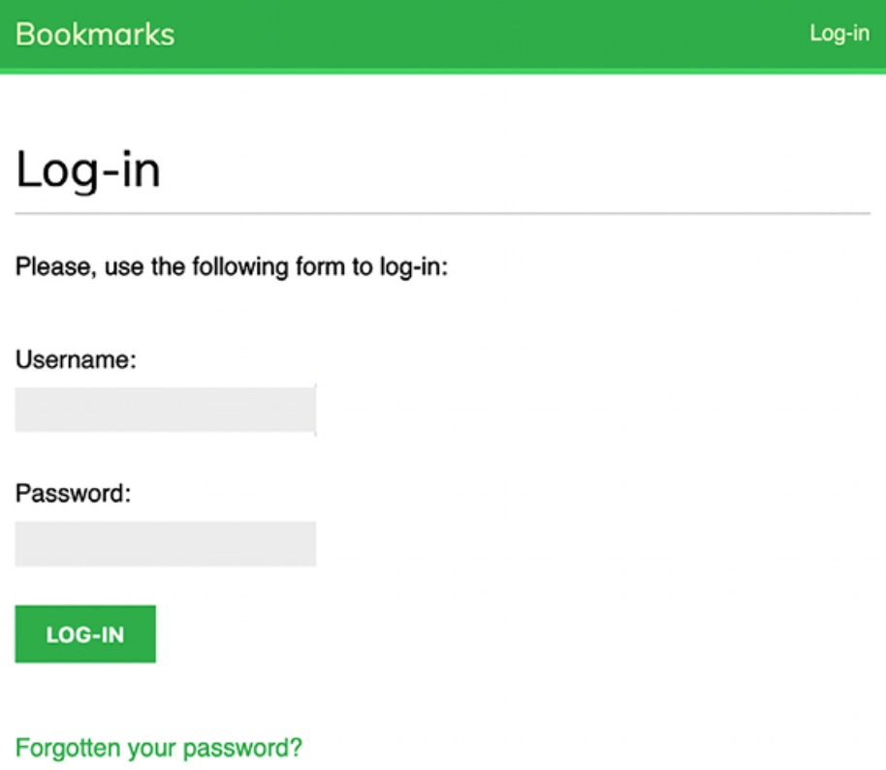
Figure 4.12: The Log-in page, including a link to the reset password page

Click on the Forgotten your password? link. You should see the following page:
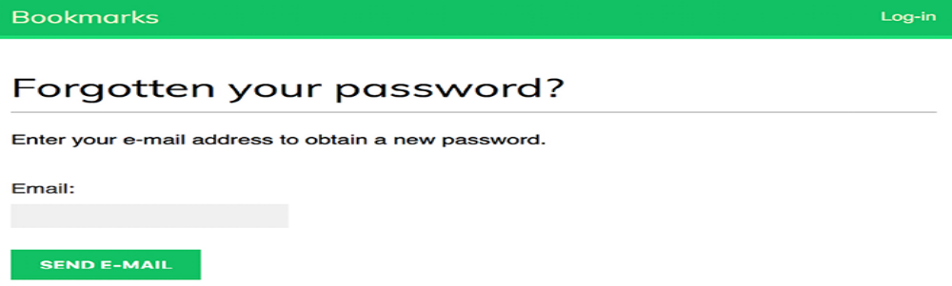
Figure 4.13: The restore password form
At this point, we need to add a Simple Mail Transfer Protocol (SMTP) configuration to the settings.py file of your project so that Django is able to send emails. You learned how to add email settings to your project in Chapter 2, Enhancing Your Blog with Advanced Features. However, during development, you can configure Django to write emails to the standard output instead of sending them through an SMTP server. Django provides an email backend to write emails to the console.

Edit the settings.py file of your project, and add the following line to it:
EMAIL_BACKEND = 'django.core.mail.backends.console.EmailBackend'

The EMAIL_BACKEND setting indicates the class that will be used to send emails.

Return to your browser, enter the email address of an existing user, and click on the SEND E-MAIL button. You should see the following page:
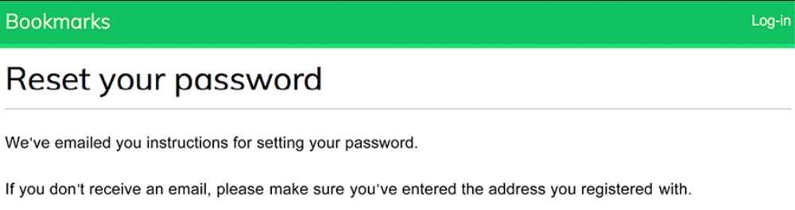
Figure 4.14: The reset password email sent page

Take a look at the shell prompt, where you are running the development server. You will see the generated email, as follows:
Content-Type: text/plain; charset="utf-8"
MIME-Version: 1.0
Content-Transfer-Encoding: 7bit
Subject: Password reset on 127.0.0.1:8000
From: webmaster@localhost
To: test@gmail.com
Date: Mon, 10 Jan 2024 19:05:18 -0000
Message-ID: <162896791878.58862.14771487060402279558@MBP-amele.lo
Someone asked for password reset for email test@gmail.com. Follow
http://127.0.0.1:8000/account/password-reset/MQ/ardx0u-b4973cfa2c
Your username, in case you've forgotten: test

The email is rendered using the password_reset_email.html template that you created earlier. The URL to reset the password includes a token that was generated dynamically by Django.

Copy the URL from the email, which should look similar to
http://127.0.0.1:8000/account/password-reset/MQ/ardx0ub4973cfa2c70d652a190e79054bc479a/ , and open it in your browser. You should see the following page:
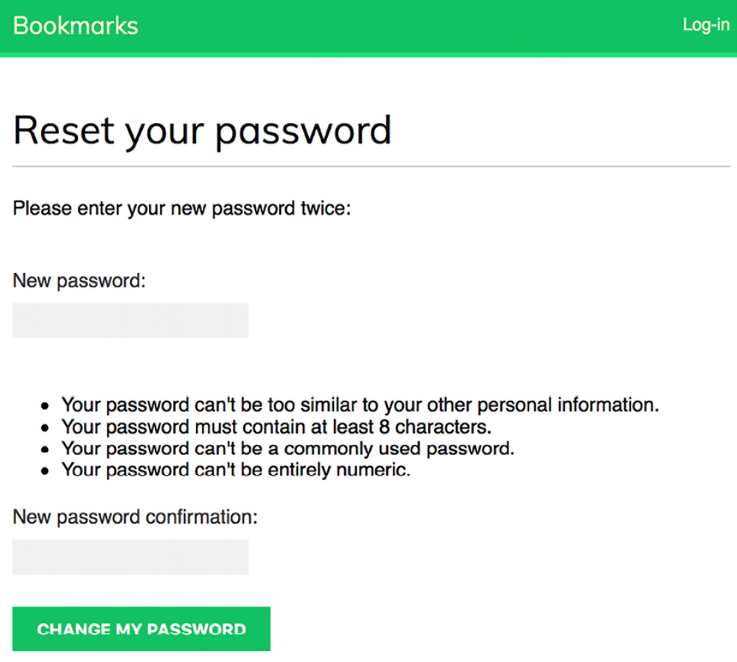
Figure 4.15: The reset password form

The page to set a new password uses the password_reset_confirm.html template. Fill in a new password and click on the CHANGE MY PASSWORD button.

Django will create a new hashed password and save it in the database. You will see the following success page:
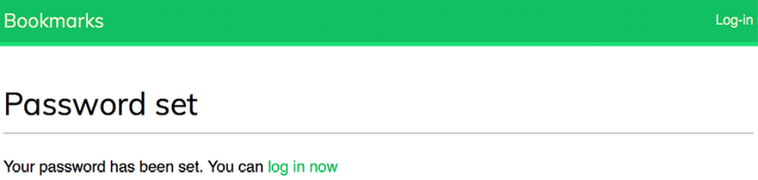
Figure 4.16: The successful password reset page

Now, you can log back into the user account using the new password. Each token to set a new password can be used only once. If you open the link that you received again, you will get a message stating that the token is invalid.

We have now integrated the views of the Django authentication framework into the project. These views are suitable for most cases. However, you can create your own views if you need different behavior.

Django provides URL patterns for the authentication views that are equivalent to the ones we just created. We will replace the authentication URL patterns with the ones provided by Django.

Comment out the authentication URL patterns that you added to the urls.py file of the account application and include django.contrib.auth.urls instead, as follows. The new code is highlighted in bold:
from django.urls import include, path
from django.contrib.auth import views as auth_views
from . import views
urlpatterns = [
# previous login view
# path('login/', views.user_login, name='login'),
# path('login/', auth_views.LoginView.as_view(), name='login'),
# path('logout/', auth_views.LogoutView.as_view(), name='logout'
# change password urls
# path(
# 'password-change/',
# auth_views.PasswordChangeView.as_view(),
# name='password_change'
# ),
# path(
# 'password-change/done/',
# auth_views.PasswordChangeDoneView.as_view(),
# name='password_change_done'
# ),
# reset password urls
# path(
# 'password-reset/',
# auth_views.PasswordResetView.as_view(),
# name='password_reset'
# ),
# path(
# 'password-reset/done/',
# auth_views.PasswordResetDoneView.as_view(),
# name='password_reset_done'
# ),
# path(
# 'password-reset/<uidb64>/<token>/',
# auth_views.PasswordResetConfirmView.as_view(),
# name='password_reset_confirm'
# ),
# path(
# 'password-reset/complete/',
# auth_views.PasswordResetCompleteView.as_view(),
# name='password_reset_complete'
# ),
path('', include('django.contrib.auth.urls')),
path('', views.dashboard, name='dashboard'),
]

You can see the authentication URL patterns included at
https://github.com/django/django/blob/stable/5.0.x/django/contrib/auth/urls.py.

We have now added all the necessary authentication views to our project.
Next, we will implement user registration.

User registration and user profiles
Site users can now log in, log out, change their password, and reset their password. However, we need to build a view to allow visitors to create a user account. They should be able to register and create a profile on our site. Once registered, users will be able to log in to our site using their credentials.

User registration
Let’s create a simple view to allow user registration on your website. Initially, you have to create a form to let the user enter a username, their real name, and a password.

Edit the forms.py file located inside the account application directory and add the following lines highlighted in bold:
from django import forms
from django.contrib.auth import get_user_model
class LoginForm(forms.Form):
username = forms.CharField()
password = forms.CharField(widget=forms.PasswordInput)
class UserRegistrationForm(forms.ModelForm):
password = forms.CharField(
label='Password',
widget=forms.PasswordInput
)
password2 = forms.CharField(
label='Repeat password',
widget=forms.PasswordInput
)
class Meta:
model = get_user_model()
fields = ['username', 'first_name', 'email']

We have created a model form for the user model. This form includes the fields username , first_name , and email of the user model. We retrieve the user model dynamically by using the get_user_model() function provided by the auth application. This retrieves the user model, which could be a custom model instead of the default auth User model, since Django allows you to define custom user models. These fields will be validated according to the validations of their corresponding model fields. For example, if the user chooses a username that already exists, they will get a validation error because username is a field defined with unique=True .

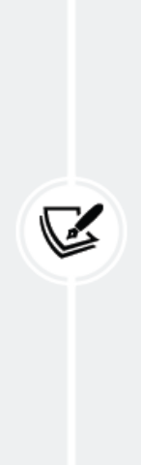
In order to keep your code generic, use the
get_user_model() method to retrieve the user model and the
AUTH_USER_MODEL setting to refer to it when defining a
model’s relationship with in to it, instead of referring to the
auth user model directly. You can read more information
about this at
https://docs.djangoproject.com/en/5.0/to
pics/auth/customizing/#django.contrib.au
th.get_user_model.

We have also added two additional fields—password and password2 —for users to set a password and to repeat it. Let’s add the field validation to check that both passwords are the same.

Edit the forms.py file in the account application and add the following clean_password2() method to the UserRegistrationForm class. The new code is highlighted in bold:
class UserRegistrationForm(forms.ModelForm):
password = forms.CharField(
label='Password',
widget=forms.PasswordInput
)
password2 = forms.CharField(
label='Repeat password',
widget=forms.PasswordInput
)
class Meta:
model = get_user_model()
fields = ['username', 'first_name', 'email']
def clean_password2(self):
cd = self.cleaned_data
if cd['password'] != cd['password2']:
raise forms.ValidationError("Passwords don't match.")
return cd['password2']

We have defined a clean_password2() method to compare the second password against the first one and raise a validation error if the passwords don’t match. This method is executed when the form is validated by calling its is_valid() method. You can provide a clean_<fieldname>() method to any of your form fields to clean the value or raise form validation errors for a specific field. Forms also include a general clean() method to validate the entire form, which is useful to validate fields that depend on each other. In
this case, we use the field-specific clean_password2() validation instead of overriding the clean() method of the form. This avoids overriding other field-specific checks that the ModelForm gets from the restrictions set in the model (for example, validating that the username is unique).

Django also provides a UserCreationForm form that resides in django.contrib.auth.forms and is very similar to the one we have created.

Edit the views.py file of the account application and add the following code
highlighted in bold:
from django.contrib.auth import authenticate, login
from django.contrib.auth.decorators import login_required
from django.http import HttpResponse
from django.shortcuts import render
from .forms import LoginForm, UserRegistrationForm
# ...
def register(request):
if request.method == 'POST':
user_form = UserRegistrationForm(request.POST)
if user_form.is_valid():
# Create a new user object but avoid saving it yet
new_user = user_form.save(commit=False)
# Set the chosen password
new_user.set_password(
user_form.cleaned_data['password']
)
# Save the User object
new_user.save()
return render(
request,
'account/register_done.html',
{'new_user': new_user}
)
else:
user_form = UserRegistrationForm()
return render(
request,
'account/register.html',
{'user_form': user_form}
)

The view for creating user accounts is quite simple. For security reasons, instead of saving the raw password entered by the user, we use the set_password() method of the user model. This method handles password hashing before storing the password in the database.

Django doesn’t store clear text passwords; it stores hashed passwords instead. Hashing is the process of transforming a given key into another value. A hash function is used to generate a fixed-length value according to a mathematical algorithm. By hashing passwords with secure algorithms, Django ensures that user passwords stored in the database require massive amounts of computing time to break.

By default, Django uses the PBKDF2 hashing algorithm with a SHA256 hash to store all passwords. However, Django not only supports checking existing passwords hashed with PBKDF2 but also supports checking stored passwords hashed with other algorithms, such as PBKDF2SHA1 , argon2 , bcrypt , and scrypt .

The PASSWORD_HASHERS setting defines the password hashers that the Django project supports. The following is the default PASSWORD_HASHERS list:
PASSWORD_HASHERS = [
'django.contrib.auth.hashers.PBKDF2PasswordHasher',
'django.contrib.auth.hashers.PBKDF2SHA1PasswordHasher',
'django.contrib.auth.hashers.Argon2PasswordHasher',
'django.contrib.auth.hashers.BCryptSHA256PasswordHasher',
'django.contrib.auth.hashers.ScryptPasswordHasher',
]

Django uses the first entry of the list (in this case, PBKDF2PasswordHasher ) to hash all passwords. The rest of the hashers can be used by Django to check existing passwords.

The scrypt hasher was introduced in Django 4.0. It is more
secure and recommended over PBKDF2 . However, PBKDF2 is
still the default hasher, as scrypt requires OpenSSL 1.1+
and more memory.

You can learn more about how Django stores passwords and about the password hashers included at
https://docs.djangoproject.com/en/5.0/topics/auth/passwords/.

Now, edit the urls.py file of the account application and add the following URL pattern highlighted in bold:
urlpatterns = [
# ...
path('', include('django.contrib.auth.urls')),
path('', views.dashboard, name='dashboard'),
path('register/', views.register, name='register'),
]

Finally, create a new template in the templates/account/ template directory of the account application, name it register.html , and make it look as follows:
{% extends "base.html" %}
{% block title %}Create an account{% endblock %}
{% block content %}
<h1>Create an account</h1>
<p>Please, sign up using the following form:</p>
<form method="post">
{{ user_form.as_p }}
{% csrf_token %}
<p><input type="submit" value="Create my account"></p>
</form>
{% endblock %}

Create an additional template file in the same directory and name it register_done.html . Add the following code to it:
{% extends "base.html" %}
{% block title %}Welcome{% endblock %}
{% block content %}
<h1>Welcome {{ new_user.first_name }}!</h1>
<p>
Your account has been successfully created.
Now you can <a href="{% url "login" %}">log in</a>.
</p>
{% endblock %}

Open http://127.0.0.1:8000/account/register/ in your browser. You will see the registration page you have created:
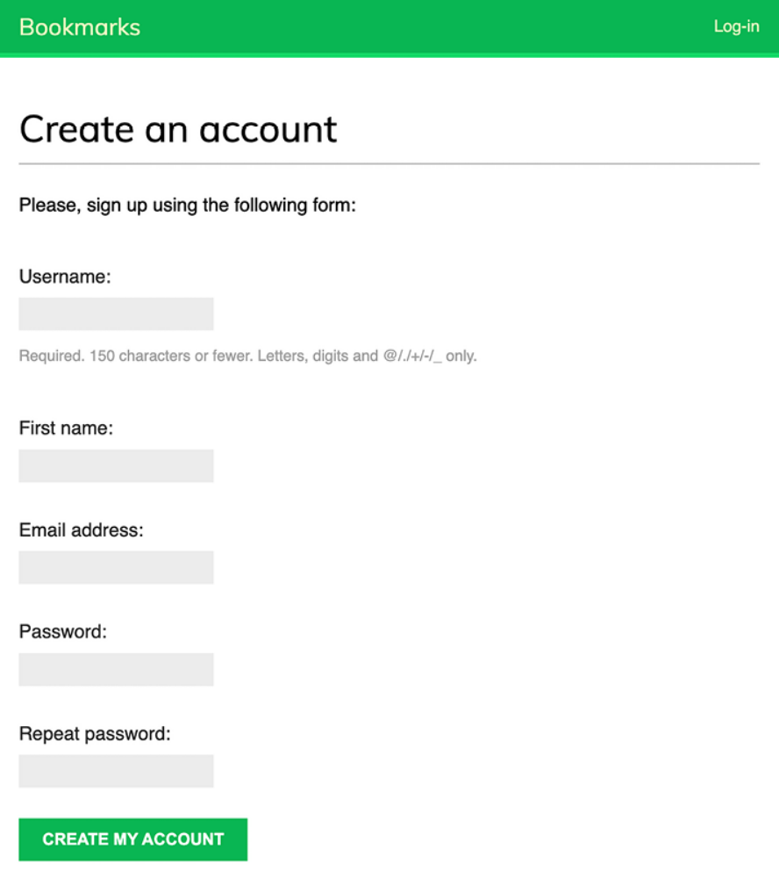
Figure 4.17: The account creation form

Fill in the details for a new user and click on the CREATE MY ACCOUNT button.

If all fields are valid, the user will be created, and you will see the following success message:
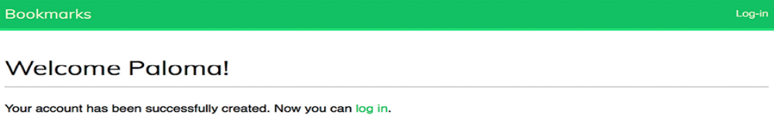
Figure 4.18: The account is successfully created page
Click on the log in link and enter your username and password to verify that you can access your newly created account.

Let’s add a link to register on the login template. Edit the registration/login.html template and find the following line:
<p>Please, use the following form to log-in:</p>

Replace it with the following lines:
<p>
Please, use the following form to log-in.
If you don't have an account <a href="{% url "register" %}">re
</p>

Open http://127.0.0.1:8000/account/login/ in your browser. The page should now look as follows:
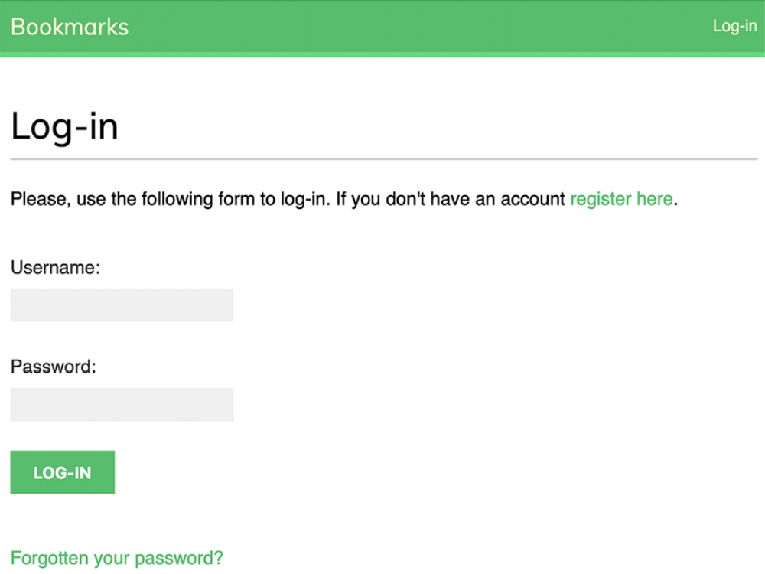
Figure 4.19: The Log-in page including a link to register

We have now made the registration page accessible from the Log-in page.

Extending the user model
While the user model provided by Django’s authentication framework is sufficient for most typical scenarios, it does have a limited set of predefined fields. If you want to capture additional details relevant to your application, you may want to extend the default user model. For example, the default user model comes with the first_name and last_name fields, a structure that may not align with naming conventions in various countries. Additionally, you may want to store further user details or construct a more
comprehensive user profile.

A simple way to extend the user model is by creating a profile model that contains a one-to-one relationship with the Django user model, and any additional fields. A one-to-one relationship is similar to a ForeignKey field with the parameter unique=True . The reverse side of the relationship is an implicit one-to-one relationship with the related model instead of a manager for multiple elements. From each side of the relationship, you access a single related object.

Edit the models.py file of your account application and add the following code highlighted in bold:
from django.db import models
from django.conf import settings
class Profile(models.Model):
user = models.OneToOneField(
settings.AUTH_USER_MODEL,
on_delete=models.CASCADE
)
date_of_birth = models.DateField(blank=True, null=True)
photo = models.ImageField(
upload_to='users/%Y/%m/%d/',
blank=True
)
def __str__(self):
return f'Profile of {self.user.username}'

Our user profile will include the user’s date of birth and an image of the user.

The one-to-one field user will be used to associate profiles with users. We use AUTH_USER_MODEL to refer to the user model instead of pointing to the auth.User model directly. This makes our code more generic, as it can operate with custom-defined user models. With on_delete=models.CASCADE , we force the deletion of the related Profile object when a User object gets deleted.

The date_of_birth field is a DateField . We have made this field optional with blank=True , and we allow null values with null=True .

The photo field is an ImageField . We have made this field optional with blank=True . An ImageField field manages the storage of image files. It validates that the file provided is a valid image, stores the image file in the directory indicated with the upload_to parameter, and stores the relative path to the file in the related database field. An ImageField field is translated to a VARHAR(100) column in the database by default. A blank string will be
stored if the value is left empty.

Installing Pillow and serving media files
We need to install the Pillow library to manage images. Pillow is the de facto standard library for image processing in Python. It supports multiple image formats and provides powerful image processing functions. Pillow is required by Django to handle images with ImageField .

Install Pillow by running the following command from the shell prompt:
python -m pip install Pillow==10.3.0

Edit the settings.py file of the project and add the following lines:
MEDIA_URL = 'media/'
MEDIA_ROOT = BASE_DIR / 'media'

This will enable Django to manage file uploads and serve media files. MEDIA_URL is the base URL used to serve the media files uploaded by users. MEDIA_ROOT is the local path where they reside. Paths and URLs for files are built dynamically by prepending the project path or the media URL to them for portability.

Now, edit the main urls.py file of the bookmarks project and modify the
code, as follows. The new lines are highlighted in bold:
from django.conf import settings
from django.conf.urls.static import static
from django.contrib import admin
from django.urls import path, include
urlpatterns = [
path('admin/', admin.site.urls),
path('account/', include('account.urls')),
]
if settings.DEBUG:
urlpatterns += static(
settings.MEDIA_URL,
document_root=settings.MEDIA_ROOT
)

We have added the static() helper function to serve media files with the Django development server during development (that is, when the DEBUG setting is set to True ).

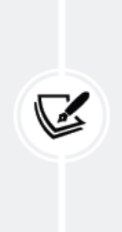
The static() helper function is suitable for development but
not for production use. Django is very inefficient at serving
static files. Never serve your static files with Django in a
production environment. You will learn how to serve static
files in a production environment in Chapter 17, Going Live.

Creating migrations for the profile model
Let’s create the database table for the new Profile model. Open the shell and run the following command to create the database migration for the new model:
python manage.py makemigrations

You will get the following output:
Migrations for 'account':
account/migrations/0001_initial.py
- Create model Profile

Next, sync the database with the following command in the shell prompt:
python manage.py migrate

You will see output that includes the following line:
Applying account.0001_initial... OK

Edit the admin.py file of the account application and register the Profile model in the administration site by adding the code in bold:
from django.contrib import admin
from .models import Profile
@admin.register(Profile)
class ProfileAdmin(admin.ModelAdmin):
list_display = ['user', 'date_of_birth', 'photo']
raw_id_fields = ['user']

Run the development server using the following command from the shell prompt:
python manage.py runserver

Open http://127.0.0.1:8000/admin/ in your browser. Now, you should be able to see the Profile model on the administration site of your project, as follows:
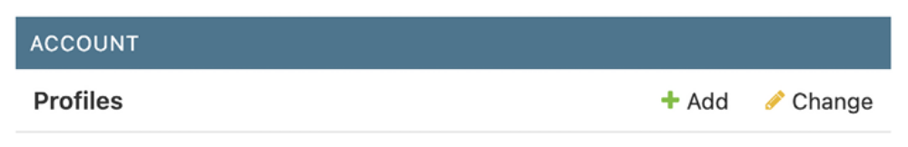
Figure 4.20: The ACCOUNT block on the administration site index page

Click on the Add link of the Profiles row. You will see the following form to add a new profile:
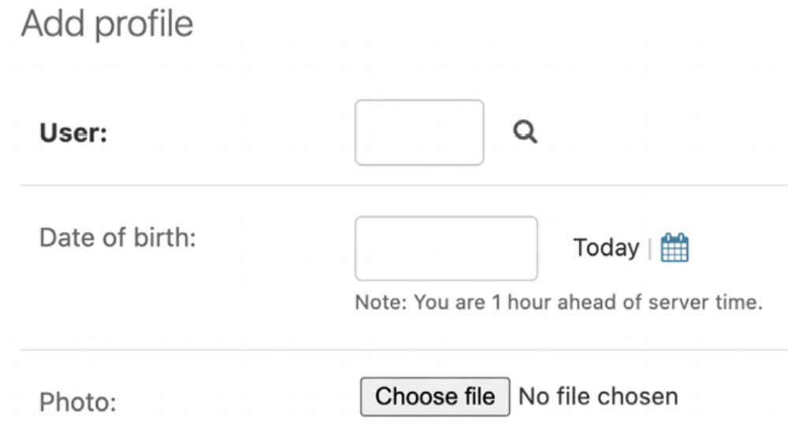
Figure 4.21: The Add profile form

Create a Profile object manually for each of the existing users in the database.

Next, we will let users edit their profiles on the website.

Edit the forms.py file of the account application and add the following lines highlighted in bold:
# ...
from .models import Profile
# ...
class UserEditForm(forms.ModelForm):
class Meta:
model = get_user_model()
fields = ['first_name', 'last_name', 'email']
class ProfileEditForm(forms.ModelForm):
class Meta:
model = Profile
fields = ['date_of_birth', 'photo']

These forms are as follows:

- UserEditForm : This will allow users to edit their first name, last name, and email, which are attributes of the built-in Django user model.

- ProfileEditForm : This will allow users to edit the profile data that is saved in the custom Profile model. Users will be able to edit their date of birth and upload an image for their profile picture.

Edit the views.py file of the account application and add the following lines highlighted in bold:
# ...
from .models import Profile
# ...
def register(request):
if request.method == 'POST':
user_form = UserRegistrationForm(request.POST)
if user_form.is_valid():
# Create a new user object but avoid saving it yet
new_user = user_form.save(commit=False)
# Set the chosen password
new_user.set_password(
user_form.cleaned_data['password']
)
# Save the User object
new_user.save()
# Create the user profile
Profile.objects.create(user=new_user)
return render(
request,
'account/register_done.html',
{'new_user': new_user}
)
else:
user_form = UserRegistrationForm()
return render(
request,
'account/register.html',
{'user_form': user_form}
)

When users register on the site, a corresponding Profile object will be automatically created and associated with the User object created. However, users created through the administration site won’t automatically get an associated Profile object. Both users with and without a profile (for example, staff users) can co-exist.

If you want to force profile creation for all users, you can use Django signals to trigger the creation of a Profile object whenever a user is created. You will learn about signals in Chapter 7, Tracking User Actions, where you will engage in an exercise to implement this feature in the section Expanding your project using AI.

Now, we will let users edit their profiles.

Edit the views.py file of the account application and add the following code highlighted in bold:
from django.contrib.auth import authenticate, login
from django.contrib.auth.decorators import login_required
from django.http import HttpResponse
from django.shortcuts import render
from .forms import (
LoginForm,
UserRegistrationForm,
UserEditForm,
ProfileEditForm
)
from .models import Profile
# ...
@login_required
def edit(request):
if request.method == 'POST':
user_form = UserEditForm(
instance=request.user,
data=request.POST
)
profile_form = ProfileEditForm(
instance=request.user.profile,
data=request.POST,
files=request.FILES
)
if user_form.is_valid() and profile_form.is_valid():
user_form.save()
profile_form.save()
else:
user_form = UserEditForm(instance=request.user)
profile_form = ProfileEditForm(instance=request.user.pro
return render(
request,
'account/edit.html',
{
'user_form': user_form,
'profile_form': profile_form
}
)

We have added the new edit view to allow users to edit their personal information. We have added the login_required decorator to the view because only authenticated users will be able to edit their profiles. For this view, we use two model forms: UserEditForm to store the data of the built-in user model and ProfileEditForm to store the additional personal data in the custom Profile model. To validate the data submitted, we call the is_valid() method of both forms. If both forms contain valid data, we save both forms by calling the save() method to update the corresponding objects in the database.

Add the following URL pattern to the urls.py file of the account application:
urlpatterns = [
#...
path('', include('django.contrib.auth.urls')),
path('', views.dashboard, name='dashboard'),
path('register/', views.register, name='register'),
path('edit/', views.edit, name='edit'),
]

Finally, create a template for this view in the templates/account/ directory and name it edit.html . Add the following code to it:
{% extends "base.html" %}
{% block title %}Edit your account{% endblock %}
{% block content %}
<h1>Edit your account</h1>
<p>You can edit your account using the following form:</p>
<form method="post" enctype="multipart/form-data">
{{ user_form.as_p }}
{{ profile_form.as_p }}
{% csrf_token %}
<p><input type="submit" value="Save changes"></p>
</form>
{% endblock %}

In the preceding code, we have added enctype="multipart/form-data" to the <form> HTML element to enable file uploads. We use an HTML form to submit both the user_form and profile_form forms.

Open the URL http://127.0.0.1:8000/account/register/ and register a new user. Then, log in with the new user and open the URL http://127.0.0.1:8000/account/edit/ . You should see the following page:
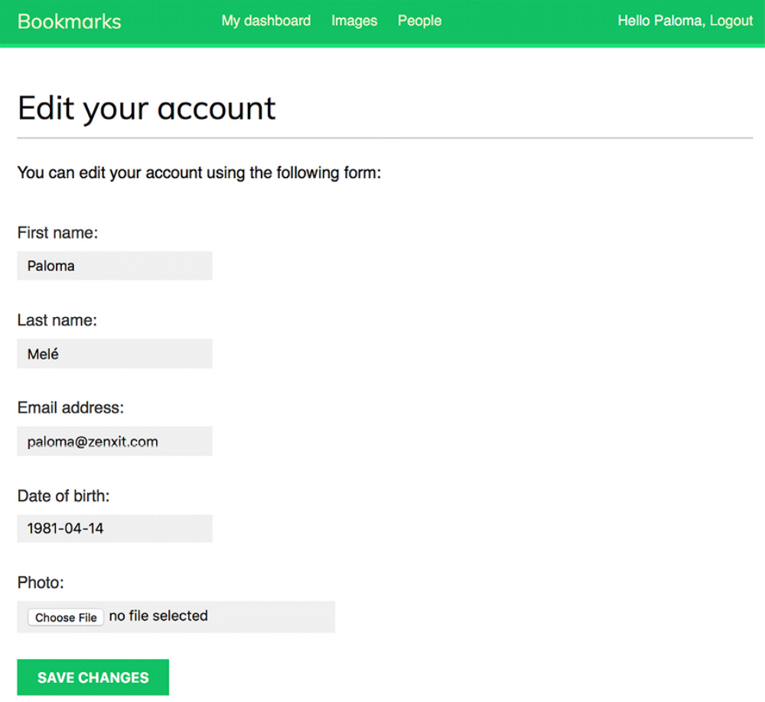
Figure 4.22: The profile edit form

You can now add the profile information and save the changes.

We will edit the dashboard template to include links to the edit profile and change password pages.

Open the templates/account/dashboard.html template and add the following lines highlighted in bold:
{% extends "base.html" %}
{% block title %}Dashboard{% endblock %}
{% block content %}
<h1>Dashboard</h1>
<p>
Welcome to your dashboard. You can <a href="{% url "edit" %}
</p>
{% endblock %}

Users can now access the form to edit their profile from the dashboard. Open http://127.0.0.1:8000/account/ in your browser and test the new link to edit a user’s profile. The dashboard should now look like this:
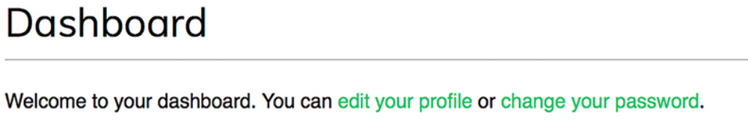
Figure 4.23: Dashboard page content, including links to edit a profile and change a password

Using a custom user model
Django also offers a way to substitute the user model with a custom model. The User class should inherit from Django’s AbstractUser class, which provides the full implementation of the default user as an abstract model. You can read more about this method at
https://docs.djangoproject.com/en/5.0/topics/auth/customizing/#substituting-a-custom-user-model.

Using a custom user model will give you more flexibility, but it might also result in more difficult integration with pluggable applications that interact directly with Django’s auth user model.

Summary
In this chapter, you learned how to build an authentication system for your site. You implemented all the necessary views for users to register, log in, log out, edit their password, and reset their password. You also built a model to store custom user profiles.

In the next chapter, you will improve the user experience by providing feedback on user’s actions through the Django messages framework. You will also broaden the scope of authentication methods, enabling users to authenticate with their email address, and integrate social authentication via Google. You will also learn how to serve the development server over HTTPS using Django Extensions, and you will customize the authentication pipeline to create user profiles automatically.
Additional resources
The following resources provide additional information related to the topics
covered in this chapter:
Source code for this chapter: ( See page 350 )

